Wolfspeed Purchase Order Number: CIP: Dept:

Supplier name:
Item Description:
After completing the requested information, please return this form to the attention of the following people: Elizabeth.Erickson@wolfspeed.com
If you have any questions, you may contact Elizabeth Erickson at (919) 407.4977.

SUPPLIER PACKAGING AND SHIPPING INSTRUCTIONS

1. Shipping Terms; Title and Risk of Loss. Shipping terms will be EXW (Incoterms 2010) designated place of pick-up if Wolfspeed’s freight forwarder loads the goods onto the initial transportation vehicle or FCA (Incoterms 2010) designated place of pick-up if Supplier loads the goods onto the initial transportation vehicle. Title and risk of loss shall pass to Wolfspeed when the goods are delivered to Wolfspeed’s freight forwarder.

2. Packaging Requirements. Supplier shall be responsible for packaging the goods in accordance with industry accepted packaging performance requirements. Further, all packaging must be appropriate for transportation by air and ground conveyances, and for ocean transit if this box is checked. Tilt indicators and impact indicators along with appropriate handling labeling must be included on all crates. All shipments must also include on the outside of the master carton a packing slip with the purchase order number listed.

3. Release of Goods. Prior to releasing the goods to Wolfspeed’s freight forwarder, Supplier will verify that the vehicle that arrives to pick up the goods is air ride equipped. If this is not the case, Supplier will immediately notify Wolfspeed and should not release the goods to the freight forwarder without Wolfspeed’s prior written authorization.

4. Shipping Information. Please complete the information requested below and return this form no later than two (2) weeks before the goods will be available for pick-up. Wolfspeed will use this information to coordinate the transportation services with the freight forwarder of its choice. Pictures should be taken of each crate showing markings and tilt/shock labels and sent to Wolfspeed Logistics before shipping.

Supplier address (where the goods will be picked up):

- Supplier contact (shipping)- name:
- Supplier contact (shipping) – phone number:
- Supplier contact (shipping) – email:
- Expected Ship Date:

Equipment Description:

Are there any lasers installed as part of the equipment? YES NO
If Yes, you must provide the FDA Accession Number:

Equipment Serial Number:
Harmonized Tariff Code:
Country of Origin:
Number of crates:
Itemized weights (net weight):
Gross weight with Dims (includes packaging):

Please provide any other special shipping requirements (i.e. air ride freight, hazmat, lift gate, etc) and/or send us as an attachment your company’s shipping requirements:

By returning this completed form, Supplier acknowledges that it has read, understands and agrees to comply with the packaging and shipping instructions set forth above and confirms that the information supplied above is accurate and complete to the best of its knowledge.

Internal Use Only:

Shipping to:

Durham MVF SCF FBF

Carsem Fayetteville RTP

Wolfspeed Crating Requirements

Scope:
To define the minimum requirements for the packaging and marking of crated tools shipping to a Wolfspeed site.

Application:
This policy is not intended to dictate how to crate the tool, it is intended to specify the minimum requirements that Wolfspeed’s suppliers need to follow to safely mitigate risk and damage during the transportation of the tool.

- Crating Requirements:
  - The maximum outside crating dimensions for airfreight are 118 inches (300cm) tall and 97 inches (246cm) wide. Please contact Wolfspeed for approval before shipping anything larger than these dimensions.
  - All shipments must be loaded on a 4-way entry skid.
  - Equipment / instruments weighing up to 2,500 kgs should be crated using the following materials:
    - 3/8" (0.95cm) thick (minimum) 3-ply plywood for the sides and covers
    - 1" x 4" (2.5cm x 10cm) wood for cleats
    - ½" (1.25cm) thick 5-ply plywood for decking
    - 2" (5cm) (nominal thickness) wood slabs for the crate’s base
  - Equipment / instruments weighing over 2,500 kgs should be crated using the following materials:
    - 1/2" (1.25cm) thick (minimum) 5-ply plywood for the sides and covers
    - 2" x 4" (5cm x 10cm) wood for cleats
    - 1" (2.5cm) thick 5-ply plywood for flooring
    - 3" (7.5cm) (nominal thickness) wood slabs for the crate’s base
  - Tool must be blocked and braced inside the crate to prevent tipping during transit
    - Tool must be bolted to the base, preferably using anchors present on the tool.
    - Top bracing is required
  - There should always be braces with foam padding against the equipment in all corners inside the crate to prevent the movement of the equipment while in transit.
  - Bubble wrap and foam can be used on sharp edges on the equipment but not under the equipment.
  - Tool should then be shrink wrapped completely
  - Barrier bag should cover the tool and be vacuum sealed to protect against the elements, in particular humidity. Barrier bag must hold vacuum. Make sure sharp edges are cushioned to protect the barrier bag from puncture.
  - Place desiccants around the bottom of the equipment inside the vacuum sealed barrier bag to collect moisture and reduce humidity. Recommended to place 1.2units/cubic foot
  - 4 Way Banding on Crates
  - Air shipments require to put 2 vents per side of crates
  - Shockwatch (2 per tool, ~18” from floor in opposite corners) are required
  - Tilt watch are required
  - For non-containerized shipments, a tarp cover is necessary to protect the tool from rain and water and to ensure that the crate will not soak water.
  - OPTIONAL: All main crates are to be on a 2in (5cm) floating cushion base with #4 ethylene foam material (of sufficient density to support the weight) either in the deck or in the skid, and the foot/base of the equipment should be bolted against the crate’s base.
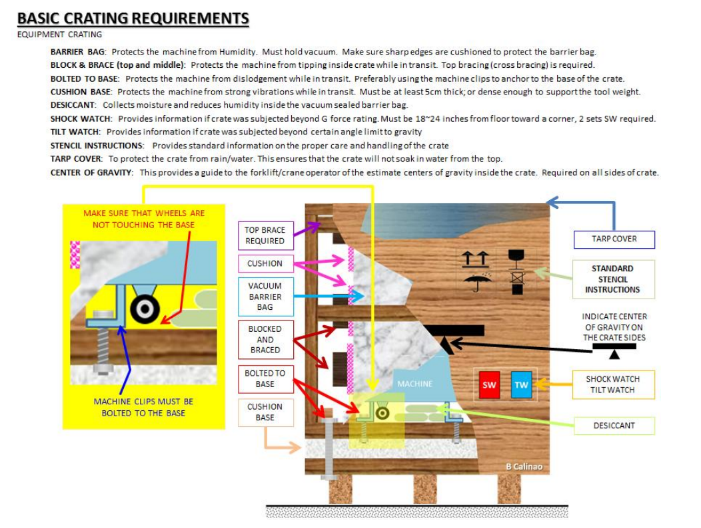

- Crate Markings
  - The following documents should be affixed to the crate in a clear waterproof packaging:
    - Packing List - showing what is in each crate, with the Wolfspeed PO# listed
    - Crating compliance checklist
  - Stencils should provide standard information on the proper care and handling of the crate
The following information should be stenciled on the outside of the crate.
Stencils should be on two opposing sides where the forklike would lift the crate from.
    - Wolfspeed Name
    - Wolfspeed Purchase Order number
    - Up Arrows
    - Box ____ of ____, Weights, Dimensions, 1/2” (1.25cm) high letters minimum
    - “Do Not Stack”
    - Estimated center of gravity on all sides to provide guidance to the carne & forklifts operators
  - The following labels should be affixed to the crates.
    - “Delicate Instruments” labels
    - “Do Not Drop” labels
    - Tiltwatch® and Tiltwatch® Companion labels placed near the bottom crate corner
    - Shockwatch® and Shockwatch® Companion labels placed above the tilt watch label.
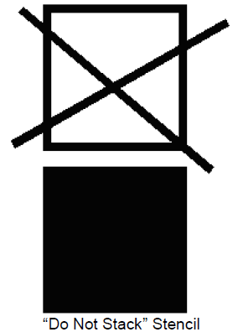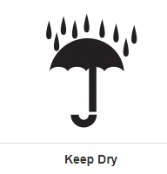

- Transportation Requirements
  - Pictures should be taken of each crate showing markings and tilt/shock labels and sent to Wolfspeed Logistics before shipping
  - All crates must to transported on air ride equipment while traveling over land
  - Shipments must be covered during ground transport with either enclosed trailers or Conestoga trailers. Step decks can be exceptions due to equipment height, but must be covered by reinforced industrial strength poly tarp and secured so that the cargo is completely covered against the elements during transport. No flat bed or low boy trailers
  - All machinery shipments transported via an enclosed trailer should be placed in a dedicated trailer and should not be co-mingled with other cargo. This approach provides additional security and minimizes the risk of other cargo shifting during transit.
  - Correct blocking and bracing within the container/trailer using wooden dunnage and chains/tension ratchet straps should be mentioned. Lashing arrangements should be made of equal material and length to ensure uniformity and effectiveness, designed to minimize forward, rearward, and lateral movement of the cargo.
  - Friction material must be utilized for machinery shipments that may experience metal-on-metal contact with a vessel or transportation equipment. It is highly recommended to use brand new rubber friction pads, mats, or similar materials, as they offer the greatest coefficient of friction. Wood can also be employed as a friction material when used in combination with robust lashing arrangements.
  - If the equipment is containerized and crated, each row of shipping units should be securely fastened using lashing straps along with blocking and bracing techniques. All void spaces within the container should be meticulously filled with air bags or secured using blocking and bracing techniques to prevent movement and potential damage.
  - For non-containerized overland transport, whether by road or rail, it is crucial to adhere to local regulations and requirements to ensure safety and compliance. For example, the FMCSA in the United States sets the minimum securing requirements for truck transport, capable of withstanding specific forces in various directions.
  - All non-containerized ocean shipments must be covered by reinforced industrial strength poly tarp and secured so that the cargo is completely covered against the elements during transport

- Material Specification
  - All wood packaging material, regardless of species, must be heat treated to meet ISPM15 standards.
  - Tilt indicator: Disposable and non-resettable
  - Shock indicator: ShockWatch® 2 impact non resettable indicators
  - Desiccant: Non-dusting type, clay or silica gel desiccant.
  - Barrier bag (MIL-PRF-131)
  - Screw nails or Ring Shank nail (No regular nails)

- Workmanship
  - All crates and components shall be free from imperfections, which may affect their utility, result in damage to the contents, or may cause injury
  - Crates shall be free of cracked, damaged, or broken fasteners
  - Nails shall not be bent or exposed and shall be driven so as not to cause the wood to split
  - Crates shall not have broken or split runners or skids.
  - Plywood shall be cut square and at no point shall the edge of the plywood extend more than 1/16 inch over or under the panel size as determined by the cleat assembly.
  - Adjacent boards in a panel shall be matched in thickness within a maximum tolerance of 1/16 inch.
  - All components shall be adequately blocked and braced to prevent shifting or movement during handling and transportation. Brackets will be required to brace system mainframes and miscellaneous components.
  - Place heavier items on the bottom of the container and the lighter or more fragile items on the top. Do not over-pack the crates.
  - Any sharp corners should be cushioned to protect the vapor barrier bag from tearing

- Damages Upon Receipt
  - Wolfspeed will immediately or as soon as practicable, document any internal damage found upon uncrating of equipment, and notify all interested parties accordingly.
  - Should internal or external damage occur in transit resulting from damage due to supplier’s improper crating, Wolfspeed may withhold payment equal to the total cost of tool installation until the installation is completed, and tool is proven to be, or not to be, production worthy.
    - At that time any additional installation costs resulting from damage due to supplier’s improper crating shall be determined per qualified engineering.
    - If the tool is deemed production worthy, Wolfspeed will release withheld funds equal to the amount of standard installation costs. All additional installation and/or inspection costs resulting from damage due to supplier’s improper crating shall be borne by the supplier.

Crating Compliance Checklist

Wolfspeed PO# ______________ Supplier _______________ Tool Name_______________

This document to be printed and included with each tool crate shipped. Verify and check the critical steps required to protect tools from the extremes of transportation and weather in transit.

Cushion Base:
Density of foam acceptable to support tool _____
Thickness of Foam on base (5cm preferred) _____

Equipment secured to bases
Bolted or _____
Blocked & Braced _____

Cross bracing at crate top _____

Barrier Bag: _____
Sharp edges cushioned to protect barrier bag _____
Barrier bag holds vacuum _____
Vapor barrier bag is wrapped with stretch wrap _____

Humidity Indicator placed on equipment _____
(Model S-8028: Levels 10, 20, 30, 40, 50, 60%)

Desiccant:
Number of desiccant bags _____
Desiccant units for each bag _____

Shock Watches:
Should be placed 18"-24" from the floor, close to a corner. Two sets of ShockWatch2's per crate on opposing corners.
25G rating of shock watch: _____
15G rating of shock watch: _____

Each crate clearly marked with:
Wolfspeed name, PO#, Weight, Center of balance, and destination address. _____

Please reference current version of Wolfspeed crating document for full spec requirements.
EXCEPTION requests: Contact Wolfspeed Procurement (Buyer) for exceptions requested to the requirements.

ORIGIN:
Inspected By ___________________________ Date of Crating ___________

